2D Ray Tracer Project

For this project I decided to use a very simple design as to not confuse the user. However I did not have time to implement all the features which I intended.

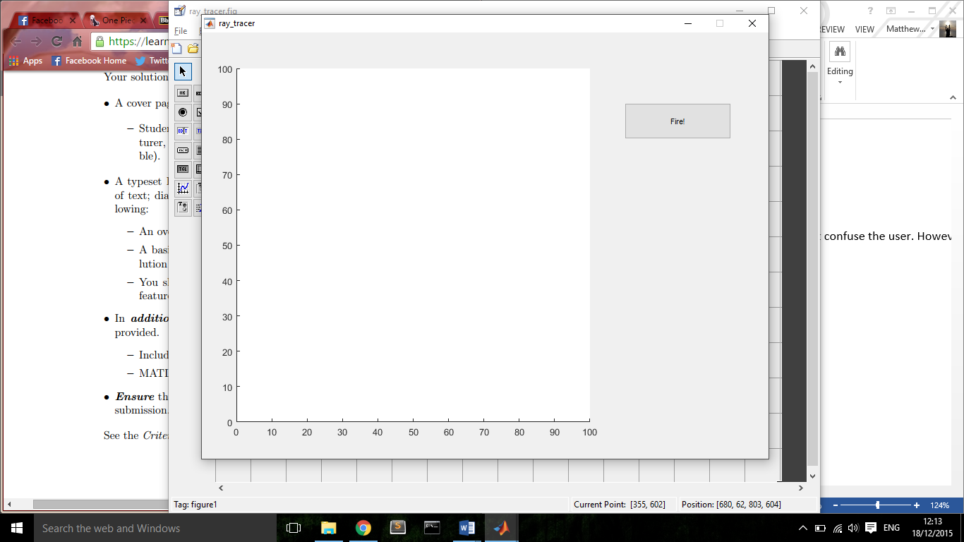

The button on the right creates the ray. The ray shoots horizontally from the 50 point on the y axis. I had planned to add two slide bars to control the incidence point of the ray and the angle at which it fires but was not able to implement this feature in time.

To add reflective elements to the gui the user must right click anywhere in the axes and options appear to add a line or a circle.

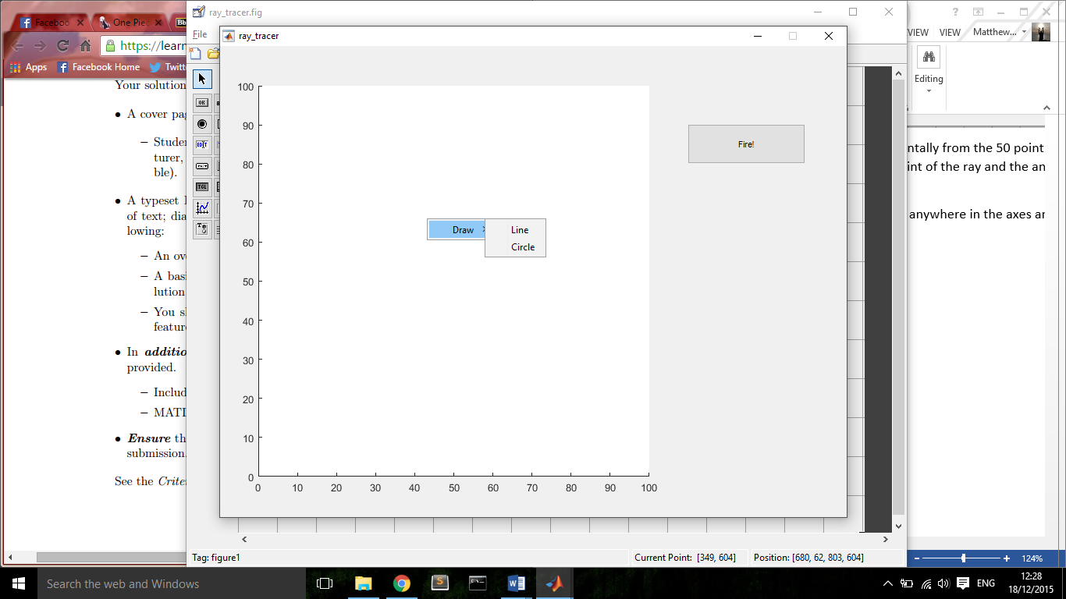

The line is created using the matlab imline function, the user has to click and hold on a point and drag the mouse to another point and release, the line is then drawn between these two points, the line can then be selected and moved and the ends of the lines become handles to resize and change the angle of the line.

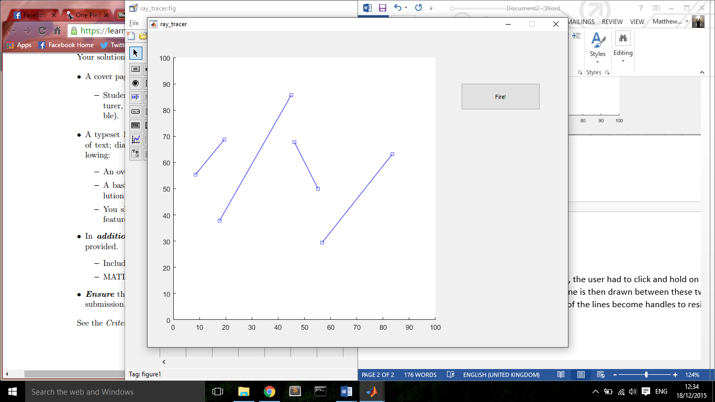

The circles had to be approached in a slightly different manner, matlab does not contain an in built circle function, however it does have one for an ellipse, imellipse. By using this function and giving values for an initial size I was able to fix the ratios so that the ellipse is forced into a circle which can then be dragged and resized by the user.

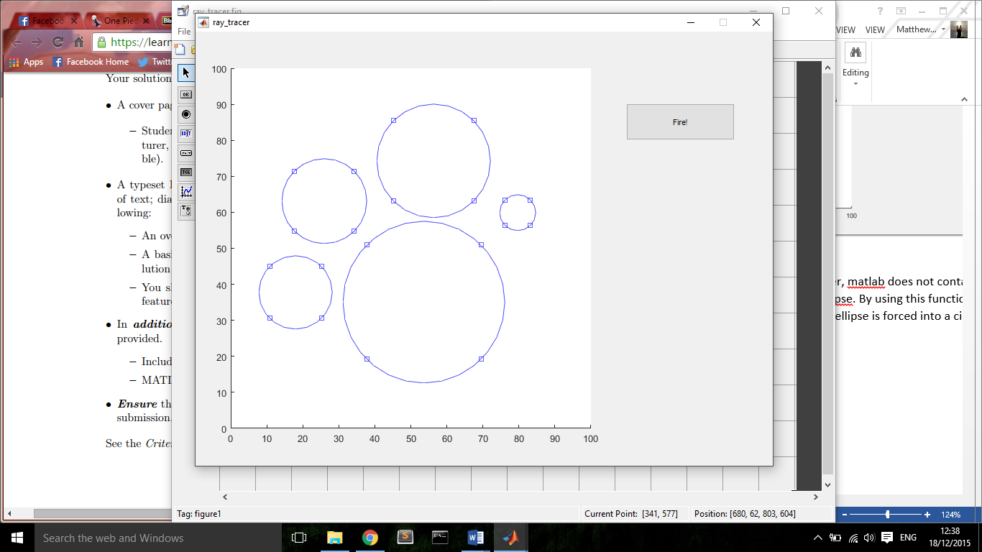

Unfortunately this was as far as I managed to get with the project and was unable to make the ray reflect off the objects.